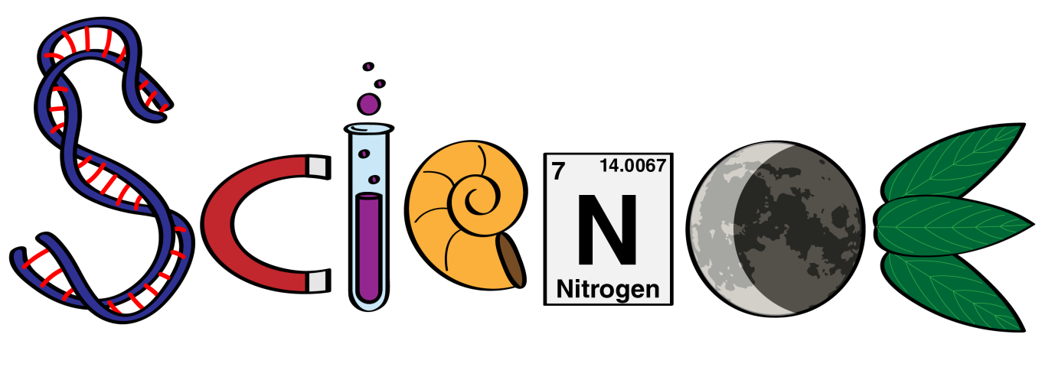
at Alderman Payne Primary School!
Is inclusive!
Creates scientists of the future.

You might hear and see…
- What’s the point?
- We are scientists!
Promotes our curiosity. It is fun and engaging.

Is practical and allows us to investigate.
Develops our scientific vocabulary and knowledge.

